**Group Name:**

Product Teams 2

**Team Members:**

Madilyn Carpenter

Tanner Elston

**Revised ERD:**

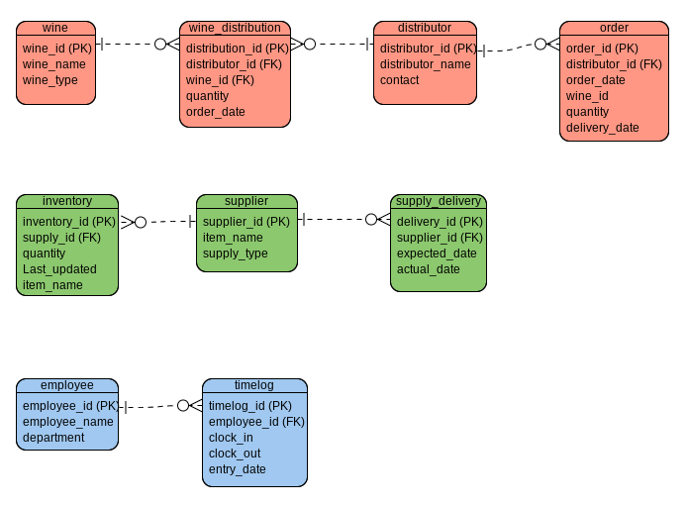

**Screenshot of Data from Tables:**

